--Discipline

--Discipline Event with the most number of students

Select a.DisciplineEventCode,a.DisciplineEventDesc, COUNT(distinct b.StudentID) AS Student_Count

from dimDisciplineEventCode a

JOIN

factDiscipline b

ON a.DisciplineEventCodeID = b.DisciplineEventCodeID

JOIN

dimStudent c

ON b.StudentID = c.StudentID

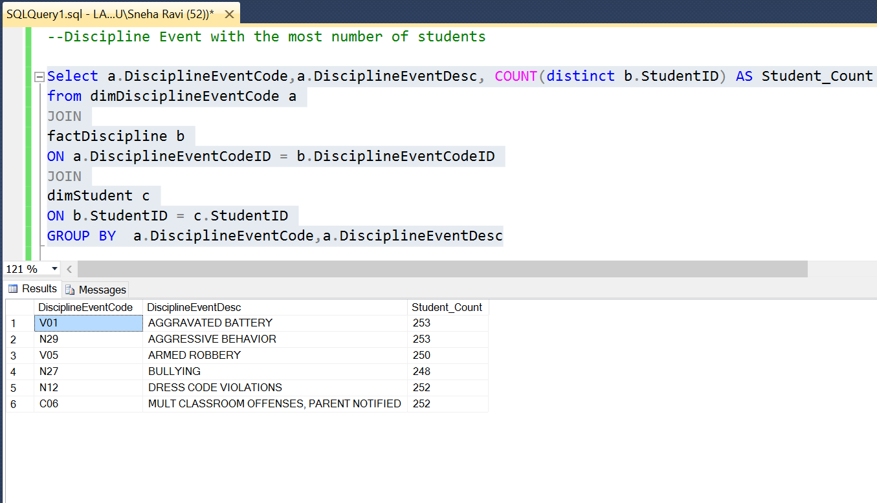GROUP BY a.DisciplineEventCode,a.DisciplineEventDesc

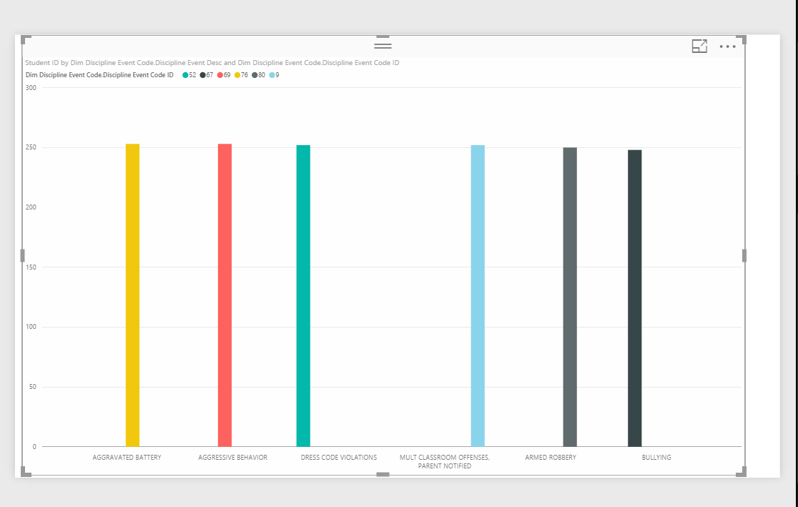

--How did different ethnic groups varying wrt DRESS CODE VIOLATIONS

--How did different ethnic groups varying wrt DRESS CODE VIOLATIONS

Select a.DisciplineEventCode,a.DisciplineEventDesc,c.Ethnicity, COUNT(distinct b.StudentID) AS Student_Count

from

(Select a.DisciplineEventCode, DisciplineEventCodeID,a.DisciplineEventDesc

from dimDisciplineEventCode a

where a.DisciplineEventCode='N12'

)a

JOIN

factDiscipline b

ON a.DisciplineEventCodeID = b.DisciplineEventCodeID

JOIN

dimStudent c

ON b.StudentID = c.StudentID

GROUP BY a.DisciplineEventCode,a.DisciplineEventDesc,c.Ethnicity

ORDER BY COUNT(distinct b.StudentID) desc

